Appsters Industry Page Layout
EDUCATION
Laid out fold by fold against www.appsters.io/industry
 | DETAIL
Slug | education-app-development
Meta Title | Education App Development Company For Schools & EdTech
Meta Description | Appsters builds eLearning apps, LMS platforms and virtual classrooms for K12, universities and training providers. Get your project estimate today.
Layout Source | www.appsters.io/industry
Live Folds | 23
New Blocks Required | 3
FOLD 1: Hero Banner
Hero Banner
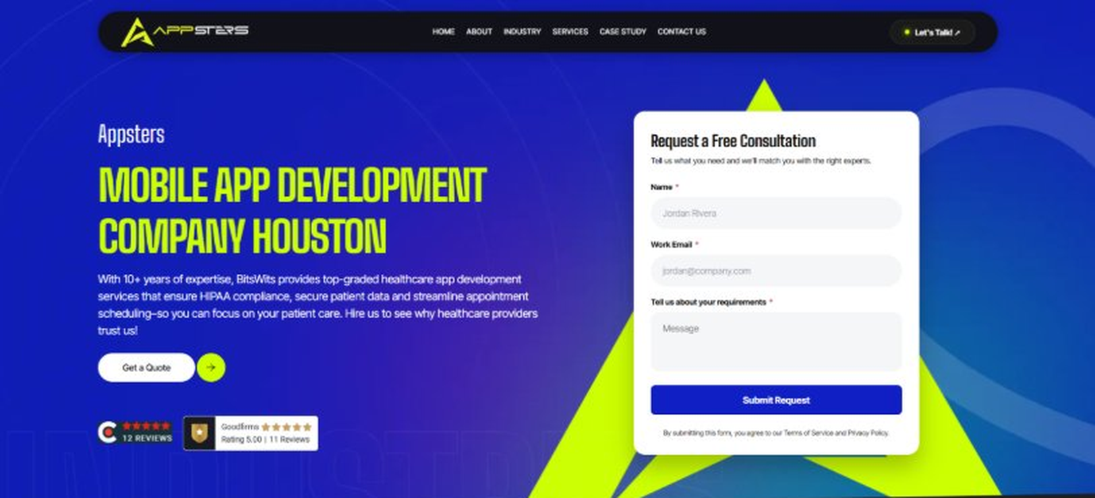
Current live page, www.appsters.io/industry
 | DETAIL
Status | New copy applied
Build Notes | Live block holds H1, sub copy, a Get a Quote button and the Request a Free Consultation form. New copy supplies the H1 and sub copy only.
QA Flag | Live hero copy currently names BitsWits and describes healthcare services. Leftover copy from another build, replace it with the new copy below.
Copy For This Fold
PAGE ELEMENT | COPY (WORD FOR WORD)
H1 (Page Heading) | A Future-Driven Education App Development Company Building Smarter Learning Products
Body Copy | Curriculum evolves faster than systems follow. As an educational app development company, Appsters designs platforms that keep students engaged, teachers informed, and learning aligned across K-12, universities, and workforce training.
FOLD 2: Marquee Strip
Marquee Strip: Turn Your Wildest Ideas Into Powerful Digital Products
Current live page, www.appsters.io/industry
 | DETAIL
Status | No copy change
Build Notes | No new copy in the source document for this fold. Keep the live block exactly as it is.
FOLD 3: Stats Counter
Stats Counter: Work With A Local Mobile App Developer In Houston
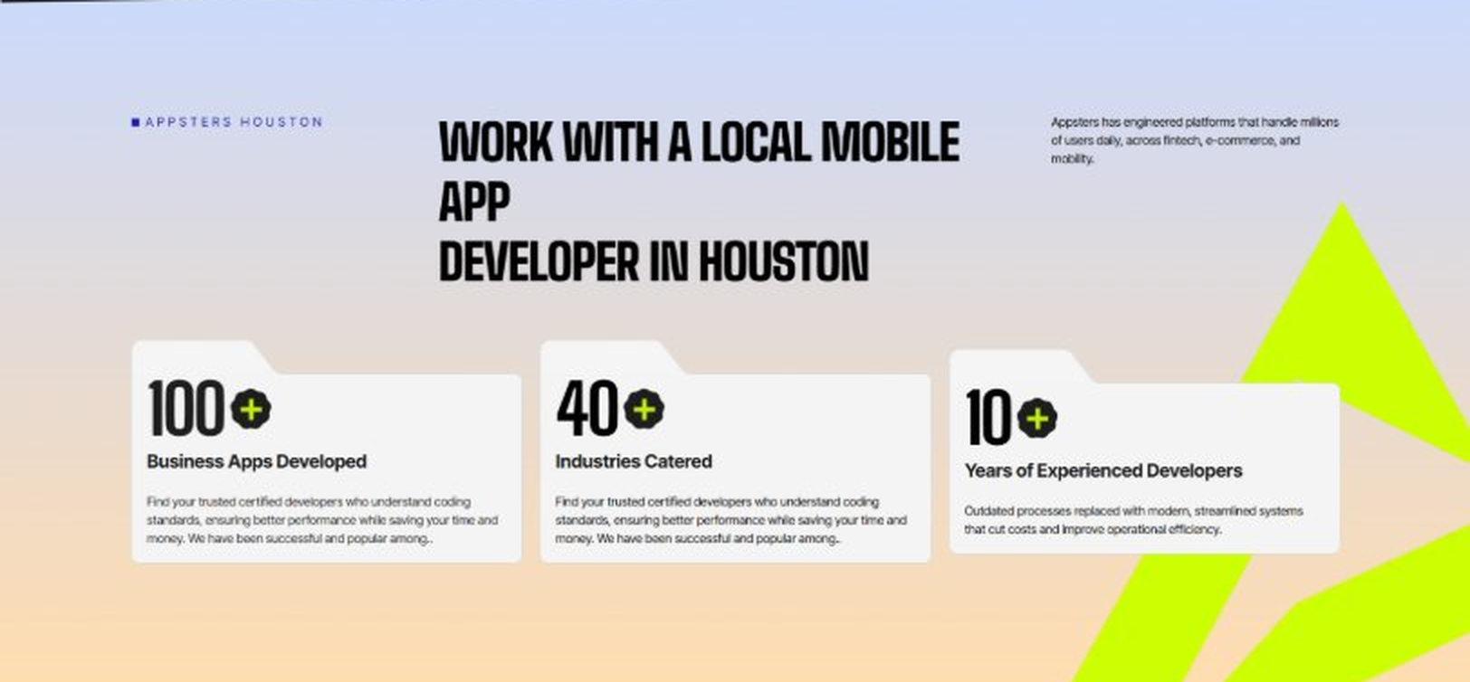
Current live page, www.appsters.io/industry
 | DETAIL
Status | New copy applied
Build Notes | Live block holds 3 counters. New copy holds 6 stats. Either widen the block to 6 or drop two.
Copy For This Fold
PAGE ELEMENT | COPY (WORD FOR WORD)
H2 (Section Heading) | Awarded For High-Impact, Data-Driven Digital Learning Products
Body Copy | Our e-learning app development work has earned awards for interactive learning design, stable classroom performance, and measurable student outcomes. Appsters has been recognized for delivering systems that balance pedagogy with engineering: platforms that load fast, adapt to learners, support structured assessments, and remain reliable for large-scale academic and corporate environments. Every win reflects tested performance, not presentation slides.
Stat 1 Number | 40+
Stat 1 Label | Industries Served
Stat 1 Copy | Our experience spans social platforms, marketplaces, fintech, healthcare, and more, with solutions adapted to each sector's demands for security, AI, compliance, and user adoption.
Stat 2 Number | 3000+
Stat 2 Label | Apps and Solutions Delivered
Stat 2 Copy | Thousands of projects executed with an emphasis on speed, AI adoption, stability, and clear ROI across both startup and enterprise environments.
Stat 3 Number | 60+
Stat 3 Label | AI Models Deployed
Stat 3 Copy | Every model is designed for high accuracy, reliable outputs, and performance at scale for mission-critical workflows and more.
Stat 4 Number | 50,000+
Stat 4 Label | Legacy Processes Modernized
Stat 4 Copy | Outdated processes replaced with modern, streamlined systems that cut costs and improve operational efficiency.
Stat 5 Number | 250+
Stat 5 Label | Engineers and Designers
Stat 5 Copy | A global team skilled in native mobile app development, AI-driven ecosystems, cross-platform builds, and enterprise architecture.
Stat 6 Number | 95%
Stat 6 Label | Client Retention
Stat 6 Copy | Long-term partnerships built on trust, consistent delivery, and continuous optimization of live applications.
FOLD 4: Marquee Strip
Marquee Strip: Mobile App Development Services
Current live page, www.appsters.io/industry
 | DETAIL
Status | No copy change
Build Notes | No new copy in the source document for this fold. Keep the live block exactly as it is.
FOLD 5: Services Grid
Services Grid: Our Comprehensive Mobile App Development Services In Houston
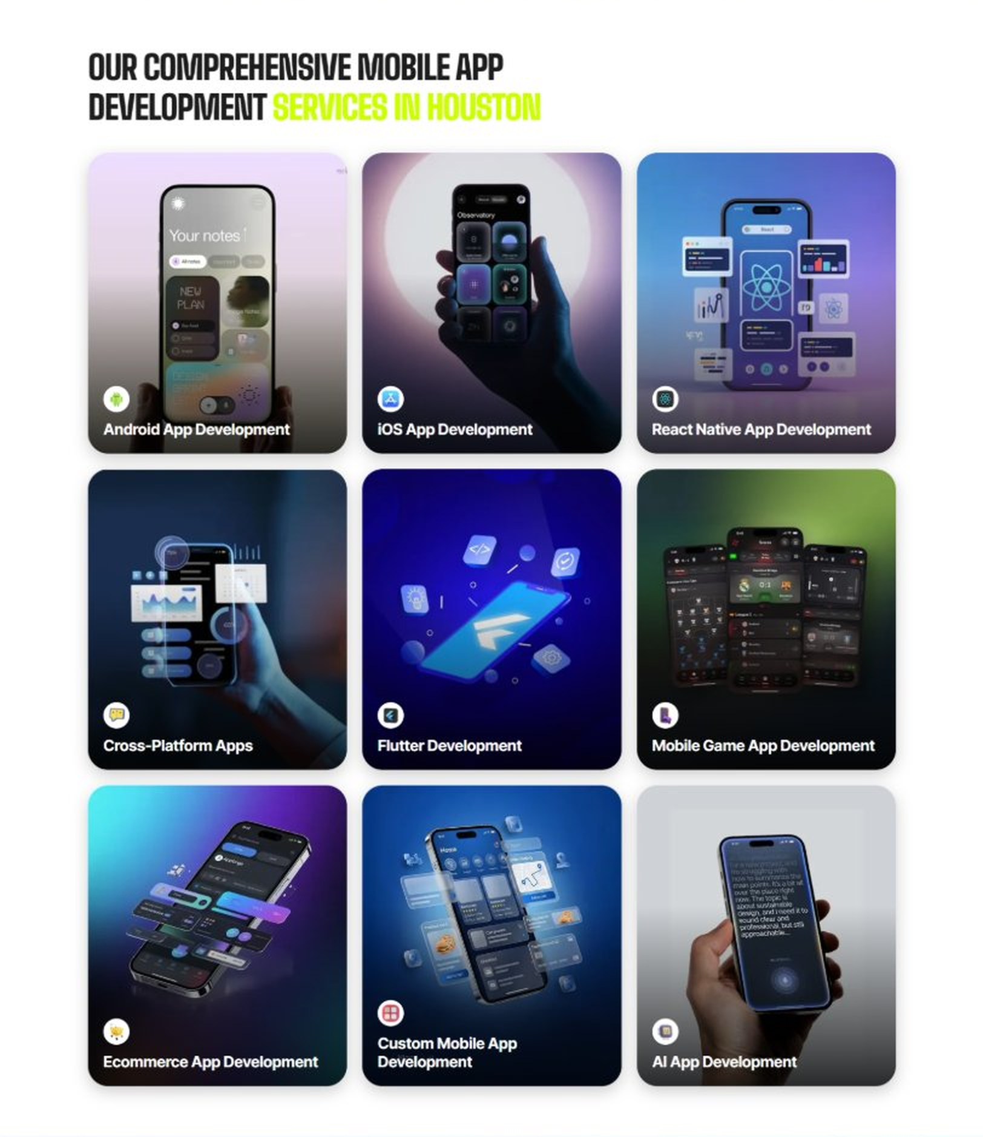
Current live page, www.appsters.io/industry
 | DETAIL
Status | New copy applied
Build Notes | Live grid holds 9 cards. New copy holds 5 services. Either trim the grid to 5 or brief four more services.
Copy For This Fold
PAGE ELEMENT | COPY (WORD FOR WORD)
H2 (Section Heading) | Educational App Development Services Built For Engaged, Outcome-Driven Learning
Body Copy | Strong learning products sit at the crossroads of curriculum, design, and engineering. Our educational app development services connect instructional design with technical precision. Appsters' senior e-learning app developers build platforms that support adaptive learning, personalized content delivery, secure progress tracking, and scalable collaboration tools for students, teachers, and enterprise trainers.
Service 1 Heading | Corporate Training App Development
Service 1 Copy | As an education app development company, we build corporate learning tools that simplify onboarding, upskilling, and compliance training. Gamified modules, progress dashboards, and micro-learning pathways keep teams engaged. Integrations with HRIS and LMS ecosystems allow managers to track outcomes cleanly. The result is training that feels relevant, measurable, and efficient across departments and devices.
Service 2 Heading | Mobile Learning App Development
Service 2 Copy | As an e-learning app development company, we create mobile-first learning experiences that adapt to learners' pace and environment. Bite-sized lessons, offline access, smart reminders, and progress sync make consistent learning simple. UX is tuned for kids, professionals, and academic learners alike. Modules become easier to manage, track, and personalize across all screen sizes.
Service 3 Heading | Custom E-Learning Solutions
Service 3 Copy | We design custom e-learning apps built around your instructional goals. Interactive modules, AI-driven recommendations, quizzes, and teacher dashboards operate within one cohesive system. Appsters builds fast-loading platforms with strong content pipelines and reliable assessment logic. Your users get an experience that makes learning structured, traceable, and genuinely engaging.
Service 4 Heading | Virtual Classroom App Development
Service 4 Copy | Appsters builds educational mobile apps that simulate real classrooms with live sessions, shared whiteboards, breakout rooms, and real-time collaboration tools. Video stability, low-latency messaging, and accessibility controls ensure teachers can run classes confidently. These platforms create consistency for students across remote, hybrid, and in-person learning environments.
Service 5 Heading | LMS Development
Service 5 Copy | Our learning management system development expertise covers full-scale academic administration: user roles, course creation, gradebooks, certificate generation, and content hosting. Appsters builds LMS platforms that integrate cleanly with SIS, CMS, and third-party learning APIs. The system stays fast, organized, and easy to manage across large schools and corporate environments.
FOLD 6: Case Study CTA
Case Study CTA: HELPP
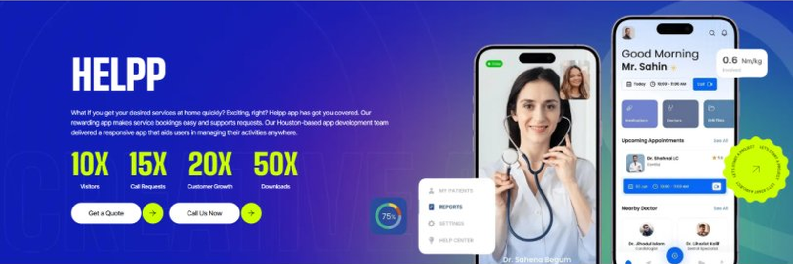
Current live page, www.appsters.io/industry
 | DETAIL
Status | New copy applied
Build Notes | Live block holds a product name, a paragraph, four metric counters and two CTA buttons. New copy supplies the heading and paragraph. Metrics still need to be supplied.
Copy For This Fold
PAGE ELEMENT | COPY (WORD FOR WORD)
H2 (Section Heading) | Advance Learning Experiences With Immersive Education Mobile App Development
Body Copy | Education is changing fast, and education mobile app development should evolve with it. If you're searching for e-learning app development services that actually move the needle, Appsters is the partner that builds what educators, parents, students, and administrators truly need. We create learning products that balance education with technical precision, giving you platforms that onboard fast, scale cleanly, and support real learner outcomes.
Body Copy 2 | Our teams design systems that feel intentional: adaptive paths for kids, deep modules for teens, collaborative tools for universities, and performance-driven content engines for professional training. Behavioral insights, curriculum logic, and the realities of modern education delivery shape every decision. You get apps that run smoothly under stress, integrate with academic ecosystems, support accessibility standards, and keep learners coming back without gimmicks. If your next learning product needs to be smarter, faster, and built with purpose, Appsters makes it happen.
FOLD 7: Testimonials
Testimonials: Real Stories From People Who Wanted What’s Next
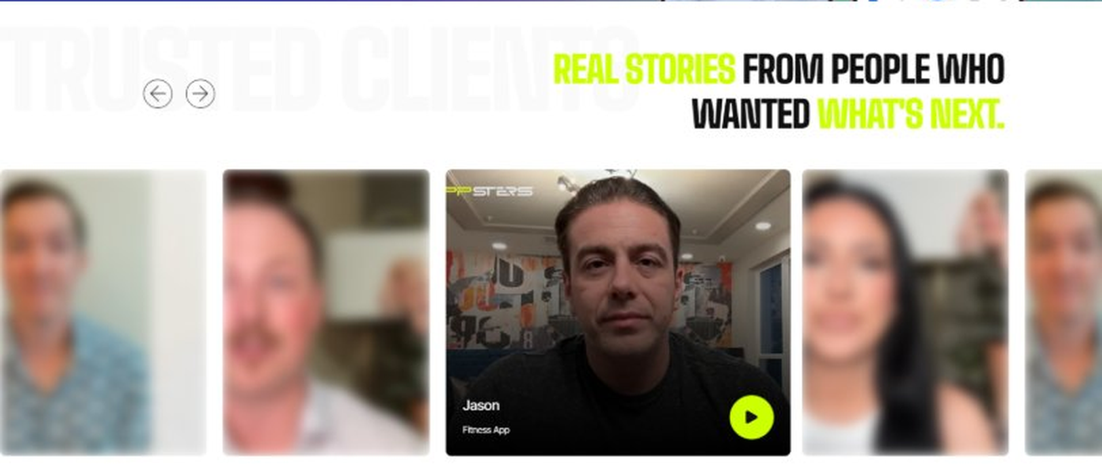
Current live page, www.appsters.io/industry
 | DETAIL
Status | New copy applied
Build Notes | Live block runs video testimonials. New copy is written quotes with attributions. Source document marks this fold design TBD.
Copy For This Fold
PAGE ELEMENT | COPY (WORD FOR WORD)
H2 (Section Heading) | See Why Stakeholders, Entrepreneurs, & Businesses Choose Our App Development & Technology Solutions
Body Copy | From founders to CTOs, businesses choose Appsters because every line of code serves a clear business purpose: growth, AI adaptability, and market edge. We measure success by the impact our solutions create, and our clients agree. From startups to global enterprises, clients trust our developers to engineer digital products that deliver progressive results.
Testimonial 1 Quote | "Appsters felt less like an agency and more like an extension of our internal product team. Their approach to education app development services gave us clarity, predictable delivery, and a platform built for real classrooms. Teachers adopted it instantly. Students stayed engaged. The entire rollout felt controlled, thoughtful, and genuinely helpful for our district."
Testimonial 1 Attribution | David Reilly, Product Owner
Testimonial 2 Quote | "We hired Appsters after cycling through two other vendors who couldn't translate our ideas. These folks did. Their instructional logic, data modeling, and content workflows finally matched how learning actually works. As an education app development company, they gave us architecture and insight that our internal team still relies on every day."
Testimonial 2 Attribution | Vanessa Hoper, Head of Curriculum Innovation
Testimonial 3 Quote | "Our K-12 ecosystem needed stable tech, fast onboarding, and strict compliance controls. Appsters delivered all three with real professionalism. Their ability to explain complex engineering choices in plain English made collaboration easy. Any education app development company can build features; these people build experiences that fit the rhythm of real classrooms."
Testimonial 3 Attribution | Joyace Keith, CEO
Testimonial 4 Quote | "We needed a mobile learning app that could scale with our user base and still feel personal. Appsters nailed personalization, pacing, analytics, everything. They treated our app as a long-term platform, not a one-off contract. This made them the perfect partner for organizations looking to build learning products that actually understand education."
Testimonial 4 Attribution | Samuel Harrington, Chief Product Strategist
Testimonial 5 Quote | "Appsters gave us a clear engineering path that supported both our academic goals and our business goals. The product now adapts to student performance with incredible accuracy. Their attention to detail and commitment to measurable improvements put them ahead of other e-learning app development companies we evaluated. The collaboration was genuinely refreshing."
Testimonial 5 Attribution | Maria Johnson, Director of Digital Learning
Source document note: Testimonial fold, design TBD after content; NOTE: two testimonials in the original had stray references to "mobile game application development company" and "hire mobile game developers," which read as leftover copy from a different vertical. Corrected to education-appropriate phrasing.
FOLD 8: Technology Logo Strip
Technology Logo Strip

Current live page, www.appsters.io/industry
 | DETAIL
Status | No copy change
Build Notes | No new copy in the source document for this fold. Keep the live block exactly as it is.
FOLD 9: Why Choose Us
Why Choose Us: Compelling Reasons To Choose Us As A Trustable App Development Company In Houston
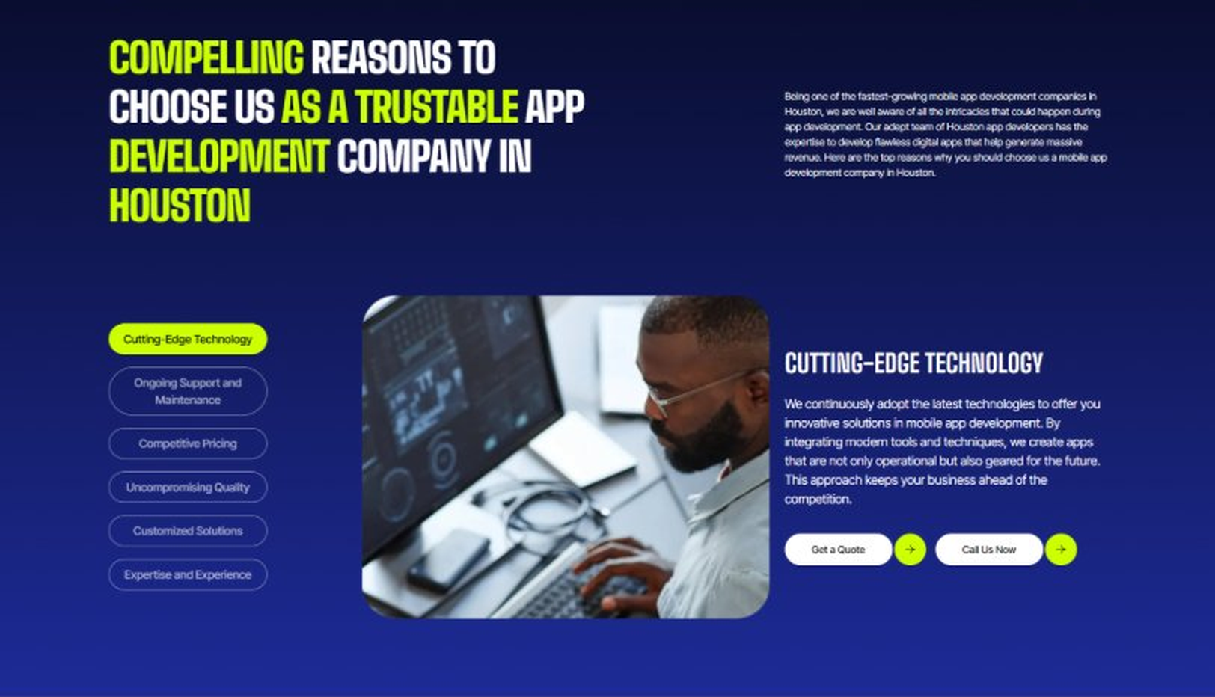
Current live page, www.appsters.io/industry
 | DETAIL
Status | New copy applied
Build Notes | Live block holds 6 tabs. New copy holds 6 reasons. Clean one to one fit, no design change needed.
Copy For This Fold
PAGE ELEMENT | COPY (WORD FOR WORD)
H2 (Section Heading) | Why Educators Choose Appsters As Their Trusted Education App Partner
Body Copy | Choosing an education app development partner shapes the future of your learners. Our team blends instructional design, engineering discipline, and platform-level thinking to build apps that deliver real learning outcomes, not vanity features.
Reason 1 Heading | Instructional Architecture Expertise
Reason 1 Copy | We align every feature with real learning science. As an educational app development company, we design interfaces and flows that mirror how students actually absorb, retain, and apply concepts.
Reason 2 Heading | Real Classroom Validation
Reason 2 Copy | We test apps inside simulated classroom environments using educator feedback loops, multi-device trials, and cohort-based review cycles. This gives institutions data they can trust.
Reason 3 Heading | Enterprise-Ready Engineering
Reason 3 Copy | Our architecture supports high concurrency, secure content delivery, and district-wide scalability. This is engineering designed for long-term adoption across large ecosystems of learners.
Reason 4 Heading | Curriculum-Centered Builds
Reason 4 Copy | We integrate standards, assessments, lesson structures, and grading systems directly into the product. Every build reflects the rhythms and demands of modern education.
Reason 5 Heading | Deep Accessibility Focus
Reason 5 Copy | Our team includes accessibility reviewers who ensure WCAG compliance and equitable use. Our e-learning app developers design for every learner, not just the median user.
Reason 6 Heading | Transparent Development Cycles
Reason 6 Copy | We follow sprint cadences with review checkpoints, roadmap visibility, and shared analytics. Clients always see what's moving, what's shipping, and what's improving.
Reason 7 Heading | Long-Term Platform Thinking
Reason 7 Copy | We structure apps as ecosystems that evolve with curriculum updates and student needs. Every release is built for longevity, not one-off delivery.
Reason 8 Heading | Unique Educator Toolkit
Reason 8 Copy | We provide teacher dashboards, grading tools, analytics, and content editors- features most teams skip. These tools make instruction easier and engagement measurable across cohorts.
FOLD 10: Sector Tabs
Sector Tabs: Serving 40+ Sectors With Mobile App Development In Houston
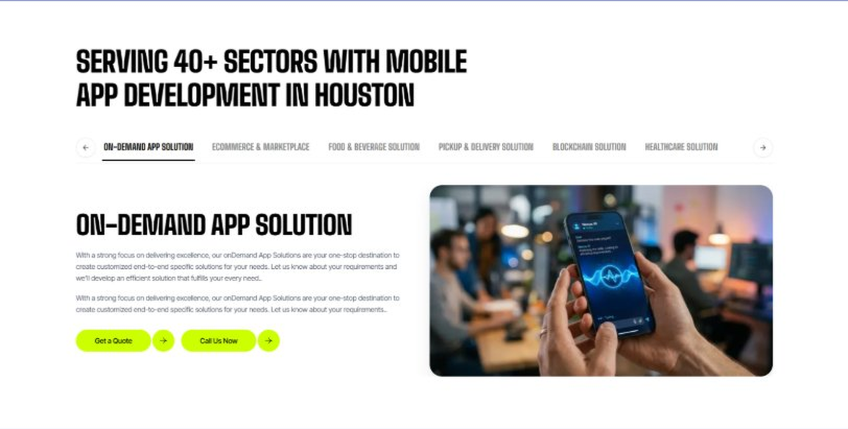
Current live page, www.appsters.io/industry
 | DETAIL
Status | New copy applied
Build Notes | Live block holds 6 sector tabs. New copy holds 5 solutions. Drop one tab or brief a sixth solution.
Copy For This Fold
PAGE ELEMENT | COPY (WORD FOR WORD)
H2 (Section Heading) | Educational App Solutions Built For Scalable Learning Ecosystems
Body Copy | Appsters delivers educational app solutions that cover everything from workforce learning to K-12 edutainment. Our systems are architected by senior education app developers who focus on cognitive engagement, accessibility, clean UX, and stable performance. We help organizations build learning platforms that feel structured, meaningful, and measurable at every level.
Solution 1 Heading | Employee Engagement Apps
Solution 1 Copy | Our employee learning platforms help organizations train teams consistently. As part of our advanced Educational App Solutions, these apps include role-based lessons, skill-gap tracking, HR integrations, micro-learning flows, and certification workflows. Each module supports measurable outcomes and delivers a smooth UX for employees at every level.
Solution 2 Heading | eLearning Apps For The Disabled
Solution 2 Copy | We create accessible eLearning apps for disabled learners with robust accessibility layers, voice navigation, sign-language modules, dyslexia-friendly fonts, color contrast controls, and motion-reduction options. Compliance with WCAG and ADA guidelines ensures every learner can interact confidently and independently.
Solution 3 Heading | On-Demand Educational Apps
Solution 3 Copy | Our On-Demand Educational Apps offer instant access to tutoring, concept videos, scheduled classes, AI-powered doubt clearing, and personalized study plans. We design them for fast response, low friction, and scale-ready architecture. These platforms support K-12, university prep, and vocational learning.
Solution 4 Heading | Content Writing & Authoring Tools
Solution 4 Copy | We build interactive Content Writing & Authoring Tools that help educators create lessons, assessments, quizzes, and digital textbooks effortlessly. These tools support multimedia upload, collaborative editing, curriculum tagging, and automatic formatting for mobile.
Solution 5 Heading | Skill-Boosting Apps
Solution 5 Copy | Our skill-boosting apps focus on employability, job-readiness, and professional upskilling through micro-learning modules, gamified assessments, portfolio building, and AI-driven progress recommendations. The experience is built to keep learners motivated while giving employers measurable insights into performance.
FOLD 11: Engagement Models Table
Engagement Models Table: Flexible Engagement Models For Any App Development Need
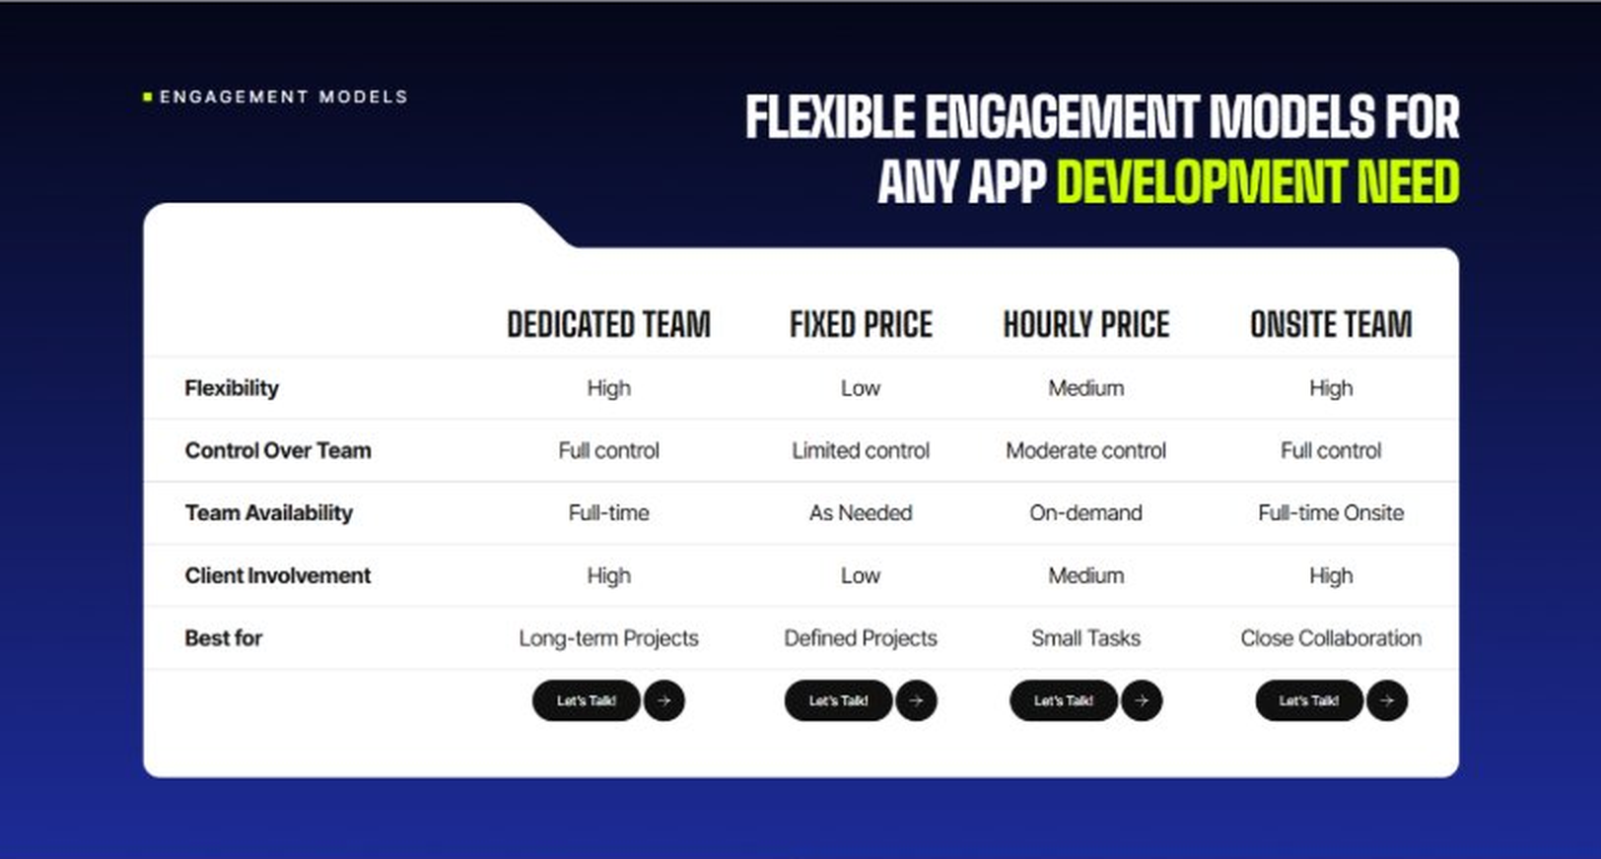
Current live page, www.appsters.io/industry
 | DETAIL
Status | No copy change
Build Notes | No new copy in the source document for this fold. Keep the live block exactly as it is.
FOLD 12: Game App CTA
Game App CTA: Into Engaging Mobile Games
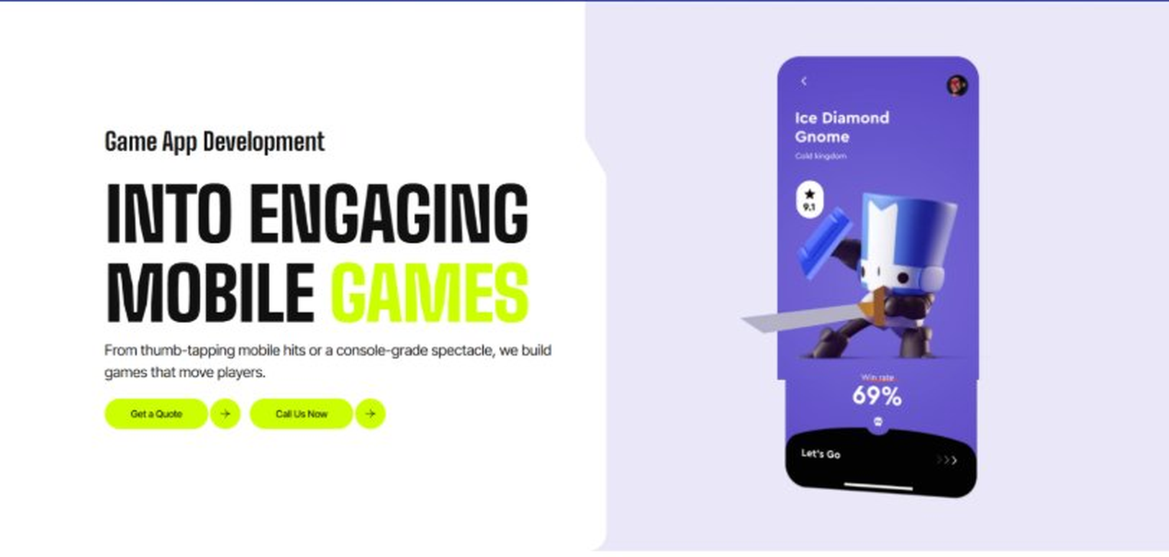
Current live page, www.appsters.io/industry
 | DETAIL
Status | No copy change
Build Notes | No new copy in the source document for this fold. Keep the live block exactly as it is.
FOLD 13: Collaboration And Client Logos
Collaboration And Client Logos
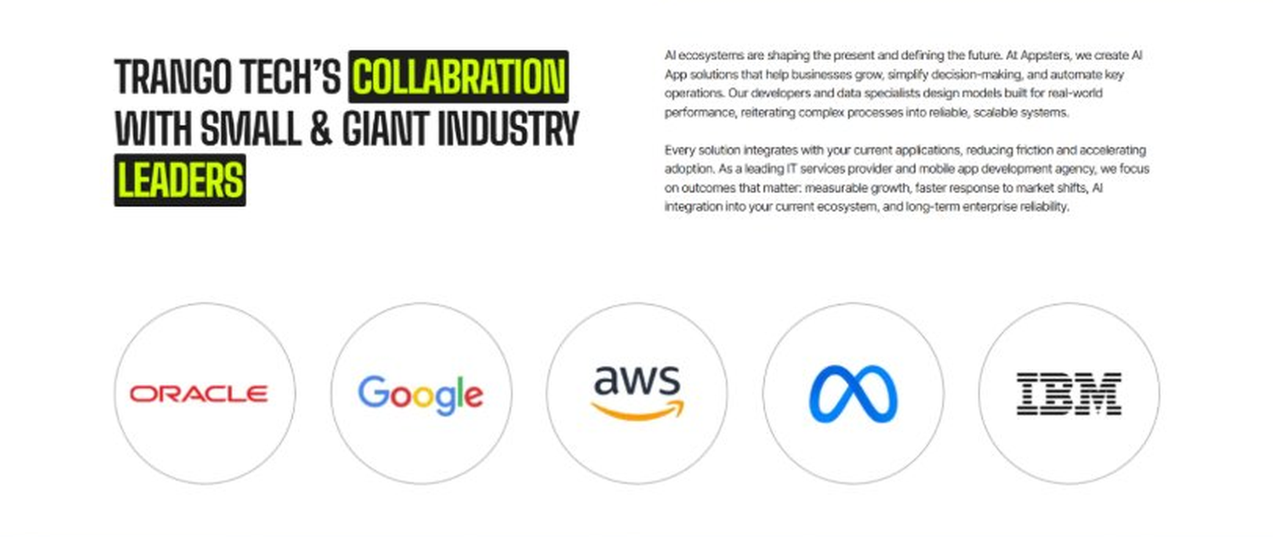
Current live page, www.appsters.io/industry
 | DETAIL
Status | No copy change
Build Notes | No new copy in the source document for this fold. Keep the live block exactly as it is.
QA Flag | Live heading reads "Trango Tech’s Collabration with Small & Giant Industry Leaders". That is a competitor name plus a spelling error sitting live on the page. Fix regardless of this content drop.
FOLD 14: Recognition CTA Banner
Recognition CTA Banner
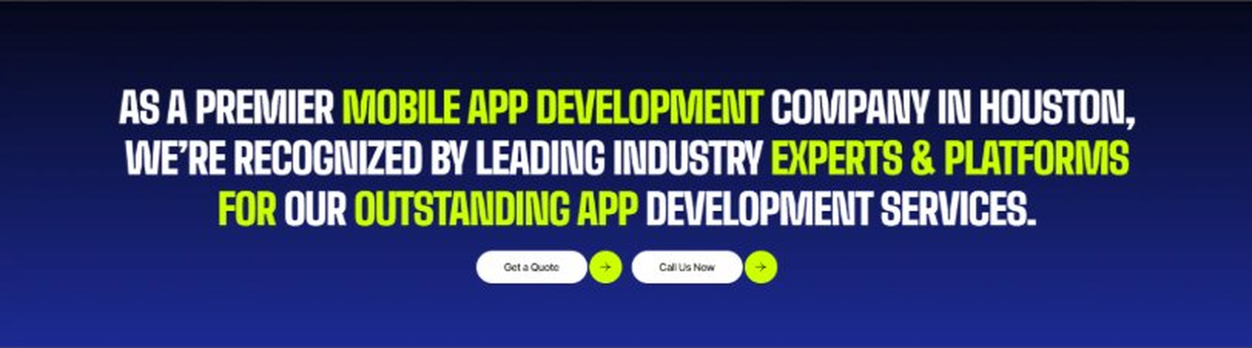
Current live page, www.appsters.io/industry
 | DETAIL
Status | New copy applied
Build Notes | Live block holds a headline and two CTA buttons. New copy supplies the heading and paragraph.
Copy For This Fold
PAGE ELEMENT | COPY (WORD FOR WORD)
H2 (Section Heading) | The Market Never Waits. Are You Ready to Launch?
Body Copy | Every day you wait is a day another platform gets ahead on engagement and outcomes. Let's build an education app that keeps learners coming back and administrators confident in the numbers. Talk to Appsters today.
FOLD 15: Market Presence And Office Map
Market Presence And Office Map: Expand Your Market Presence
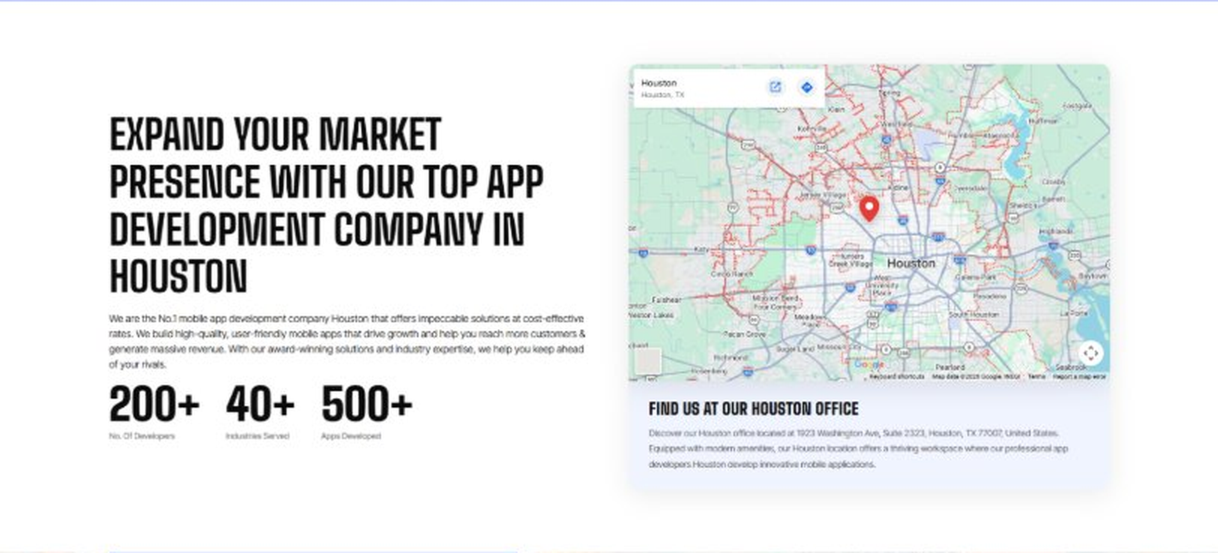
Current live page, www.appsters.io/industry
 | DETAIL
Status | New copy applied
Build Notes | Live block holds a heading, a paragraph, three counters and the office map. New copy supplies the heading and paragraph.
Copy For This Fold
PAGE ELEMENT | COPY (WORD FOR WORD)
H2 (Section Heading) | E-learning App Developers Building Reliable, Scalable Learning Stacks
Body Copy | At Appsters, our engineering stack is built for the real world of education delivery, where lesson flow, device variation, student attention, and institutional standards all collide in a single product that must run flawlessly every day.
Body Copy 2 | Our teams use Swift, Kotlin, Flutter, React Native, Unity, WebRTC, LTI support, SCORM packaging, AI-driven recommendation engines, and FERPA-friendly cloud infrastructures to develop mobile apps for students that behave predictably under load.
Body Copy 3 | Unlike most educational app development companies, we integrate pedagogy, analytics, accessibility, and long-term scalability into one system so your learning product grows without breaking the experience.
FOLD 16: Portfolio
Portfolio: Quick Glimpse On Our Portfolio

Current live page, www.appsters.io/industry
 | DETAIL
Status | New copy applied
Build Notes | Live block holds a heading, a paragraph and one CTA. New copy holds an intro plus 4 named product cards. Source document marks this fold design TBD.
Copy For This Fold
PAGE ELEMENT | COPY (WORD FOR WORD)
H2 (Section Heading) | Education Products Engineered For Real Learning Impact
Body Copy | Appsters builds learning platforms that behave like long-term ecosystems. Our solutions stand out because they blend pedagogy, engineering, accessibility, and student behavior analytics in one stable system. Every product is architected for performance, retention, and emotional relevance across K-12, higher education, corporate training, and edutainment.
Product 1 Heading | LearnQuest
Product 1 Copy | LearnQuest is an interactive early-learning platform designed for pre-K to grade 3 students. The app blends phonics, colors, math basics, and storytelling into guided learning paths. Adaptive difficulty keeps each child comfortably challenged, while parents and teachers receive clean progress dashboards. Built-in accessibility features support diverse learners, and low-latency interactions ensure attention stays on learning, not on navigating screens.
Product 2 Heading | CampusCruze
Product 2 Copy | CampusCruze is a university-grade mobile learning ecosystem for lectures, assignments, attendance, and digital campus workflows. Students can access lesson recordings, take quizzes, join discussion rooms, and receive faculty updates in real time. A structured backend ensures stable performance during high-load events like exam periods. Designed with FERPA-friendly architecture, it keeps academic data protected while giving institutions the flexibility to scale effortlessly.
Product 3 Heading | SkillForge
Product 3 Copy | SkillForge is an upskilling and micro-credentialing app built for working professionals. Users get structured learning tracks, practical projects, progress tracking, and certification workflows that sync with HR systems. Gamified assessments and real-time scoring help maintain engagement. The backend supports large organizations with high user concurrency, clean analytics pipelines, and expandable content libraries built for long-term retention.
Product 4 Heading | ReadingGalaxy
Product 4 Copy | ReadingGalaxy is an immersive reading and comprehension app powered by AR overlays and guided narration. Students explore stories spatially, interact with vocabulary prompts, and complete comprehension challenges in real time. Built with accessibility in mind, it supports dyslexia-friendly modes, offline reading, and classroom-level assignments. Teachers can manage groups, push tasks, and monitor reading fluency development seamlessly.
Source document note: Portfolio fold, design TBD after content
FOLD 17: Tech Stack Tabs
Tech Stack Tabs: Mobile App Development, A Tech Stack For The Bold
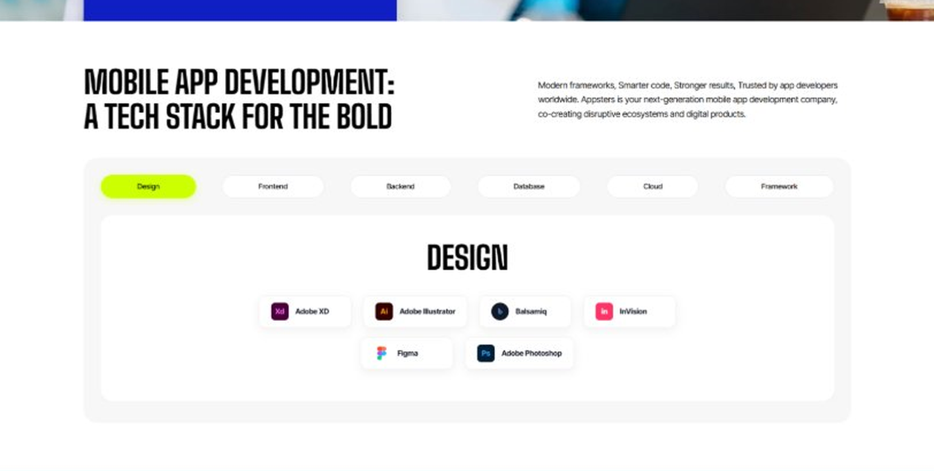
Current live page, www.appsters.io/industry
 | DETAIL
Status | New copy applied
Build Notes | Live block holds 6 category tabs with tool logos. New copy supplies the heading and paragraph, the tab contents stay as they are.
Copy For This Fold
PAGE ELEMENT | COPY (WORD FOR WORD)
H2 (Section Heading) | Technology Stack That Powers High-Performance Education Applications
Body Copy | Our engineering foundation supports large classrooms, complex learning paths, and institution-wide scalability. Through our education application development services, we use Swift, Kotlin, Flutter, React Native, Node.js, Python, secure cloud infrastructure, offline-first content delivery, and adaptive learning engines. Every stack decision reinforces stability, accessibility, and long-term flexibility so schools, universities, and EdTech teams can grow without rebuilding.
FOLD 18: Process
Process: App Development Process
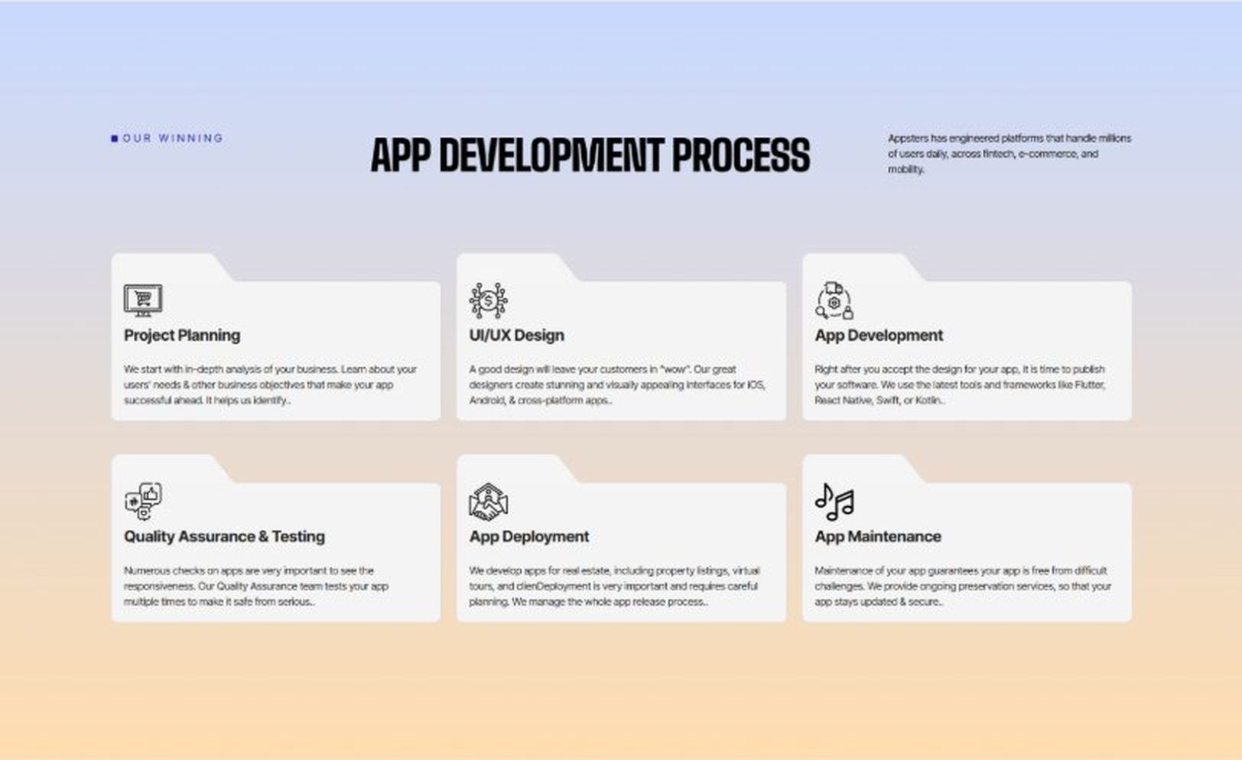
Current live page, www.appsters.io/industry
 | DETAIL
Status | New copy applied
Build Notes | Live block holds 6 step cards. New copy holds 8 steps. Either widen the block to 8 or merge two steps.
Copy For This Fold
PAGE ELEMENT | COPY (WORD FOR WORD)
H2 (Section Heading) | An Education App Development Process Engineered For Real Learning Outcomes
Body Copy | A successful platform needs more than clean code. It needs structure, clarity, and a process engineered for pedagogy, compliance, and long-term stability. Our education app development process aligns product goals with technical roadmaps so every phase, from ideation to release, moves with intention. As an educational app development company, we plan with educators, test with students, and engineer systems built for sustained engagement across all learning environments.
Step 1 Heading | App Idea & Research
Step 1 Copy | Every project begins with structured discovery, where our teams map learning objectives, audience behavior, curriculum rules, device environments, and administrative needs. As an educational app development company, we benchmark competitor patterns, test student engagement models, and define content-delivery flows that align with actual learning science. By the time the research phase closes, the product's purpose, constraints, risks, and growth paths are already crystal clear.
Step 2 Heading | Strategic Planning & Consultation
Step 2 Copy | Here, we translate research into a measurable plan. Our strategists define the instructional architecture, technology stack, accessibility requirements, assessment logic, and delivery milestones. Institutions often rely on us to clarify how mobile apps for e-learning should function across teachers, students, and administrators. By aligning requirements with realistic engineering workloads, planning becomes a force multiplier rather than a formality.
Step 3 Heading | Wireframing & Prototyping
Step 3 Copy | We turn ideas into tangible user journeys. Wireframes capture navigation, interaction design, cognitive load, and learning pathways in a visual structure that stakeholders can evaluate. As an educational app developer, we test flows with sample users where needed and refine elements like module pacing, quiz logic, and content hierarchy. The prototype becomes a shared truth: everyone sees the same product before a single line of code is written.
Step 4 Heading | App Development
Step 4 Copy | This is where engineering takes over. Our developers implement the final UI, content engines, gamification logic, LMS features, video modules, offline support, analytics events, and secure account systems. As a seasoned education app development agency, we enforce coding standards, add monitoring hooks, and conduct incremental reviews that protect long-term scalability. Development stays transparent, sprint-driven, and deeply aligned with your educational goals.
Step 5 Heading | Expert QA & Testing
Step 5 Copy | Quality assurance covers far more than bug hunting. We validate accessibility, screen reader compatibility, classroom network resilience, device fragmentation, concurrent lesson handling, assessment accuracy, and parental control logic. For mobile apps for e-learning, we simulate real classroom chaos: dropped connections, low-end devices, multitasking interruptions, and peak-load sessions. Only stable, predictable behavior earns approval.
Step 6 Heading | App Launch
Step 6 Copy | Launch is a coordinated rollout, not a final step. We manage store compliance, COPPA/FERPA guidelines, metadata strategy, onboarding flow polishing, and final performance checks. As an educational app development company, we also prepare institution-ready deployment materials, admin guides, and analytics dashboards so educators have clarity from day one. Launch becomes a controlled expansion, not a risky leap.
Step 7 Heading | Deployment
Step 7 Copy | Our deployment pipelines are built for consistency and safety. We configure cloud infrastructure, optimize CDNs for media-heavy content, calibrate autoscaling, secure APIs, and integrate LMS or SIS systems where required. Deployment includes telemetry setup, role-based access controls, and operational runbooks so your team can maintain, extend, and support the app without friction.
Step 8 Heading | Maintenance & Support
Step 8 Copy | Post-launch, we continue where most teams stop. We monitor engagement patterns, track module performance, refine lesson pacing, improve UI clarity, and respond to new education standards or school requirements. As a dedicated educational app developer, our support covers bug fixes, feature extensions, curriculum updates, server optimization, and version management that keep your learning ecosystem evolving at the pace of real classrooms.
Source document note: Process fold, design TBD after content
FOLD 19: Blog Posts
Blog Posts: Our Related Blog Posts
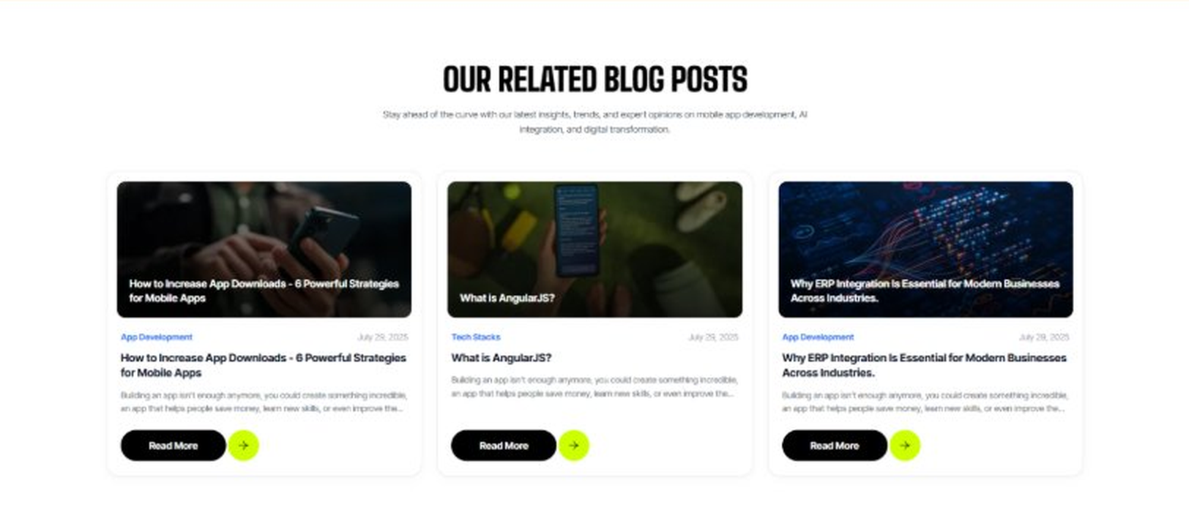
Current live page, www.appsters.io/industry
 | DETAIL
Status | No copy change
Build Notes | No new copy in the source document for this fold. Keep the live block exactly as it is.
FOLD 20: FAQs
FAQs: Your Questions, Our Clarity
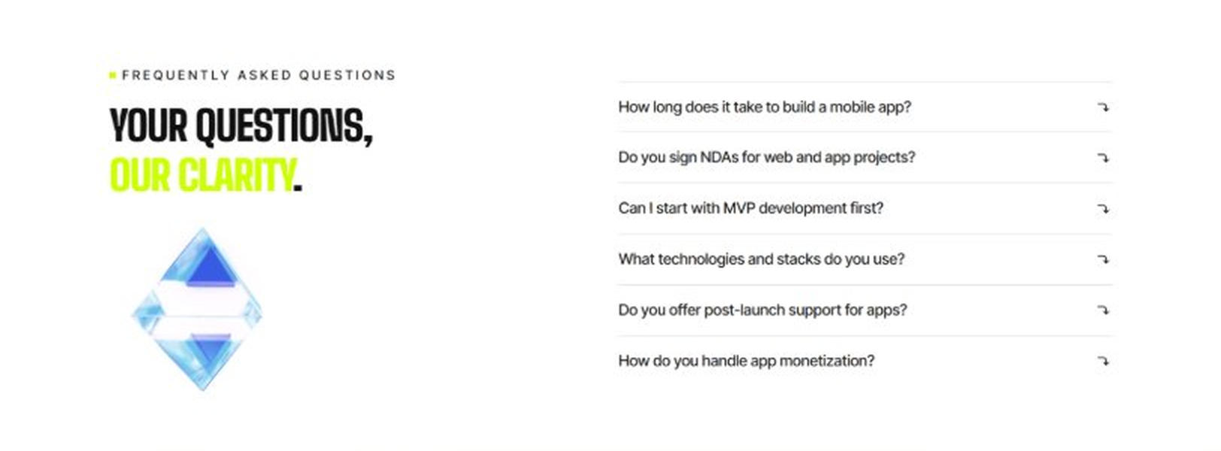
Current live page, www.appsters.io/industry
 | DETAIL
Status | New copy applied
Build Notes | Live block holds 6 accordion rows. New copy holds 6 questions and answers. Clean one to one fit.
Copy For This Fold
PAGE ELEMENT | COPY (WORD FOR WORD)
H2 (Section Heading) | Frequently Asked Questions
FAQ 1 Question | How long does it typically take to build a fully functional education app?
FAQ 1 Answer | Timelines depend on instructional complexity, integrations, content engines, and testing depth. Most projects take 12 to 20 weeks for a stable release, including design, engineering, QA, and pilot onboarding. As an education app development company, we provide clear milestones from day one.
FAQ 2 Question | Can Appsters integrate LMS, SIS, and third-party learning tools into one unified system?
FAQ 2 Answer | Yes. We support deep integration with LMS platforms, SIS databases, assessment engines, content repositories, and secure identity systems. As an experienced e-learning app development company, we architect clean data flows so institutions don't manage fragmented ecosystems or duplicate learning pipelines.
FAQ 3 Question | Do you build custom modules for interactive and gamified learning experiences?
FAQ 3 Answer | Absolutely. We design custom mechanics for quizzes, simulations, rewards, adaptive difficulty, and collaborative tasks. Our team ensures each module aligns with real learning goals. As an educational app development company, we build engagement systems that feel natural rather than distracting.
FAQ 4 Question | How does Appsters ensure data privacy and compliance for student information?
FAQ 4 Answer | We implement encryption, access controls, auditing, FERPA compliance strategies, and secure cloud configurations. Testing covers network risk, user identity flow, and content permissions. As an e-learning app development company, we design every solution to protect sensitive data at scale.
FAQ 5 Question | Can Appsters support multi-school or enterprise-level deployments with high user concurrency?
FAQ 5 Answer | Yes. We architect for large cohorts, multi-tenant structures, and heavy concurrent usage during peak school hours. As an education app development agency, our infrastructure choices ensure stability across districts, campuses, and national-level EdTech deployments.
FAQ 6 Question | What level of customization do you offer for curriculum-based learning platforms?
FAQ 6 Answer | We support complete customization, including lesson sequencing, assessment logic, teacher dashboards, accessibility features, and analytics depth. Institutions can shape every layer. As an educational app developer, we design platforms that reflect each client's academic vision.
FOLD 21: Locations
Locations: Our Global Presence
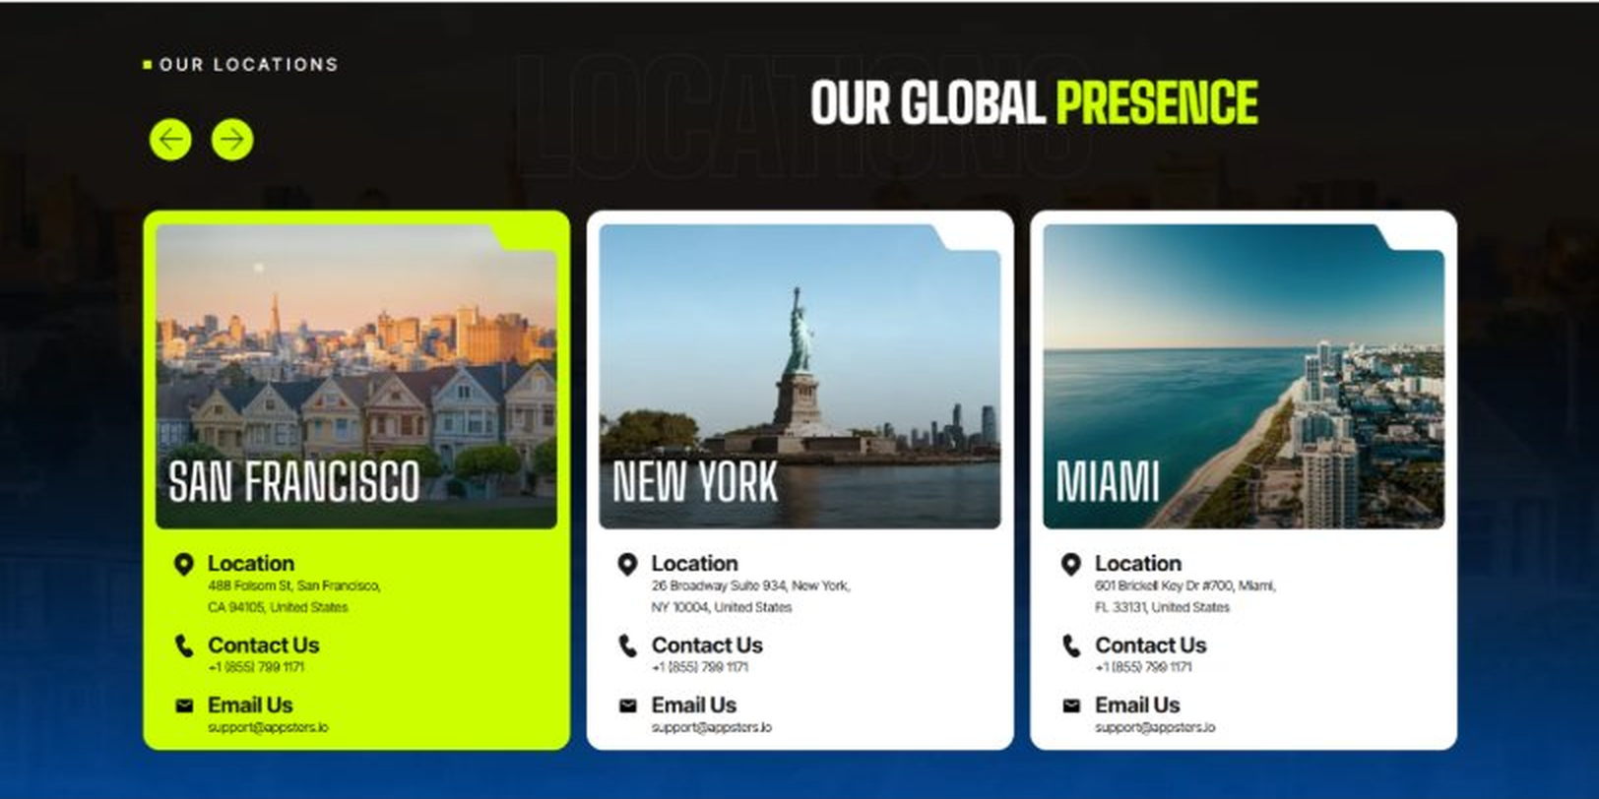
Current live page, www.appsters.io/industry
 | DETAIL
Status | No copy change
Build Notes | No new copy in the source document for this fold. Keep the live block exactly as it is.
FOLD 22: Contact Form
Contact Form: Connect With Us
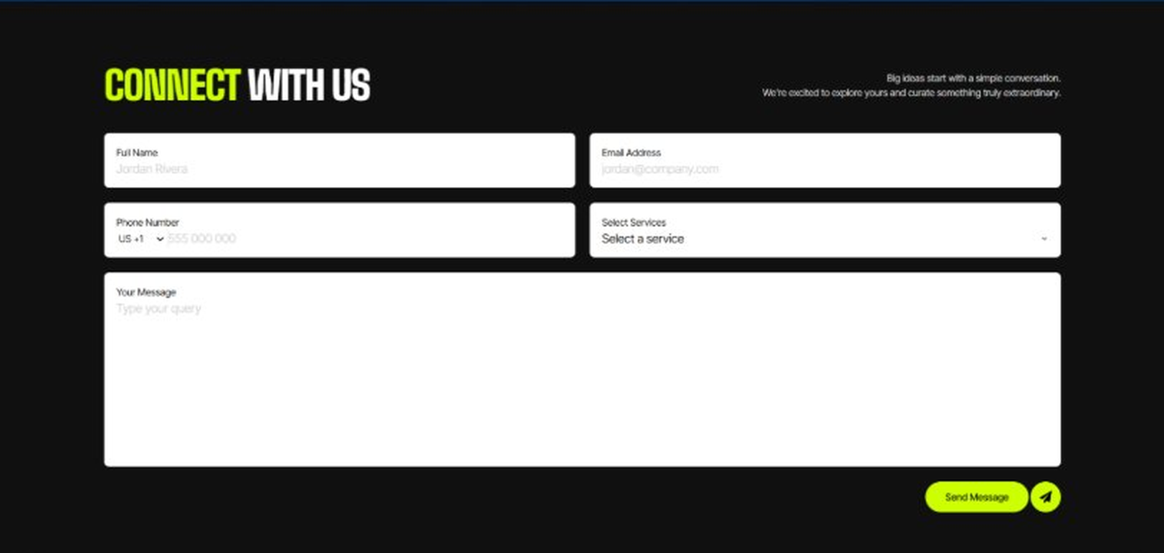
Current live page, www.appsters.io/industry
 | DETAIL
Status | No copy change
Build Notes | No new copy in the source document for this fold. Keep the live block exactly as it is.
FOLD 23: Footer
Footer
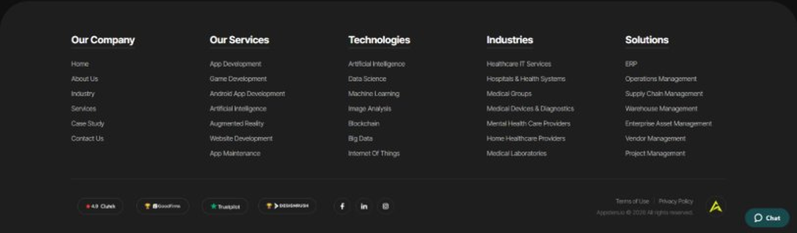
Current live page, www.appsters.io/industry
 | DETAIL
Status | No copy change
Build Notes | No new copy in the source document for this fold. Keep the live block exactly as it is.
NEW BLOCKS REQUIRED
The three blocks below are in the source content but have no matching section anywhere on the current /industry page. Each one needs a new block built.
NEW BLOCK: Building Apps Like The World's Top Learning Platforms But Sharper
 | DETAIL
Status | No equivalent block on the live page
Placement | Suggested placement: directly after Fold 5, reusing the services card grid styling.
Copy For This Block
PAGE ELEMENT | COPY (WORD FOR WORD)
H2 (Section Heading) | Building Apps Like The World's Top Learning Platforms But Sharper
Body Copy | Educational platforms evolve fast. Our role is to engineer the next generation of these experiences. We study the mechanics behind the most successful learning apps and build improved, modern, adaptive versions shaped around deeper engagement and measurable outcomes.
Feature 1 Heading | Udemy
Feature 1 Copy | We build platforms like Udemy with stronger instructor dashboards, adaptive content sequencing, richer analytics, and cohort-based learning tools. Our approach adds structured learning paths, peer collaboration modules, and more refined assessment systems so learners stay engaged longer and educators can measure progress with precision.
Feature 2 Heading | Duolingo
Feature 2 Copy | We create language-learning apps inspired by Duolingo but with advanced phonics engines, speech-recognition pipelines, personalized reinforcement loops, and culture-context modules. The experience becomes more immersive and more human, blending game mechanics with structured linguistic progression for stronger retention across all age groups.
Feature 3 Heading | Coursera
Feature 3 Copy | Our Coursera-style apps combine academic-grade program delivery with enterprise-ready engineering. We bring in certification workflows, institution onboarding, interactive modules, and real-time feedback tools. The result feels more fluid, more responsive, and more adaptable to universities wanting custom, scalable online learning ecosystems.
Feature 4 Heading | Khan Academy
Feature 4 Copy | We build Khan-inspired platforms with deeper mastery tracking, enhanced teacher dashboards, and adaptive difficulty engines. Students receive real-time guidance, educators receive actionable insights, and institutions get an ecosystem that scales seamlessly across grades, devices, and subject areas.
Feature 5 Heading | Kahoot!
Feature 5 Copy | We deliver game-based learning apps similar to Kahoot! but enhanced with AI-generated quizzes, real-time multiplayer load balancing, teacher moderation tools, and accessible gameplay logic. The result is a more dynamic, more inclusive, and more high-energy learning environment tailored for classrooms and remote sessions alike.
NEW BLOCK: Industries We Serve
 | DETAIL
Status | No equivalent block on the live page
Placement | Suggested placement: directly after Fold 10, as a card grid rather than tabs.
Copy For This Block
PAGE ELEMENT | COPY (WORD FOR WORD)
H2 (Section Heading) | Industries We Serve
Body Copy | One Codebase. Infinite Industries. Where Every Industry Finds Its Edge. Our web, app, gaming, and AI solutions are built to perform, scale, and adapt while setting industry standards and redefining what's possible for businesses everywhere.
Industry 1 Heading | Healthcare
Industry 1 Copy | We develop HIPAA-compliant healthcare apps that bridge doctors, patients, and data. From telemedicine to AI-powered diagnostics, our solutions improve workflows, reduce wait times, and empower smarter, faster decision-making. Every feature is designed to keep patient privacy airtight while driving measurable results for hospitals, clinics, and health-tech startups.
Industry 2 Heading | Fintech
Industry 2 Copy | We co-create secure, compliant fintech apps that simplify payments, investments, and trading. From blockchain-backed wallets to AI fraud detection, our solutions prioritize speed, trust, and transparency. We help financial institutions and startups scale confidently, turning complex transactions into seamless user journeys with powerful analytics and risk-free automation.
Industry 3 Heading | Education
Industry 3 Copy | Our education apps gamify learning, power virtual classrooms, and track student progress. We integrate AR/VR modules, quizzes, and real-time assessments to boost engagement. Schools, universities, and ed-tech startups leverage our platforms to personalize teaching, improve retention, and make learning as interactive and rewarding as social media scrolling.
Industry 4 Heading | Real Estate
Industry 4 Copy | We design real estate apps that help buyers, sellers, and agents close deals faster. AR-powered property tours, AI-driven recommendations, and secure document management streamline every step. Our platforms keep listings fresh, negotiations quick, and users delighted, turning real estate buying and selling into a guided, data-driven experience.
Industry 5 Heading | Automotive
Industry 5 Copy | From fleet management dashboards to car rental apps, we digitize automotive operations. IoT sensors, real-time tracking, and predictive maintenance keep vehicles safer and downtime lower. Our solutions put dealerships, logistics providers, and automakers in the driver's seat of efficiency, customer experience, and future mobility innovation.
Industry 6 Heading | Music
Industry 6 Copy | We create streaming apps, artist marketplaces, and licensing solutions that let music businesses scale and monetize. AI-powered recommendations, offline playback, and fan engagement features keep listeners hooked. Our process covers rights management, secure distribution, and seamless playback to hit the perfect balance between creativity, tech, and revenue.
Industry 7 Heading | Social Media
Industry 7 Copy | We build social media platforms that are scalable, sticky, and secure. AI-driven feeds, privacy-first chat systems, and live content features drive engagement. Our architecture ensures your platform can handle viral moments without crashing, giving creators, communities, and brands a digital stage to connect and grow.
Industry 8 Heading | Logistics
Industry 8 Copy | We power logistics apps with route optimization, GPS tracking, and real-time inventory sync. Our solutions cut costs, eliminate bottlenecks, and ensure every delivery meets its deadline. Carriers, 3PLs, and warehouses rely on us to bring transparency, speed, and automation to complex supply chains across industries.
Industry 9 Heading | Ecommerce
Industry 9 Copy | We build ecommerce apps that sell more with frictionless checkouts, AI product recommendations, and mobile-first design. Our solutions handle scale effortlessly, from flash sales to global launches. Businesses get powerful dashboards, while shoppers get a personalized, smooth, and secure experience that turns carts into conversions.
NEW BLOCK: Advanced Integrations That Enhance Every Education App We Build
 | DETAIL
Status | No equivalent block on the live page
Placement | Suggested placement: directly after Fold 17, reusing the services card grid styling.
Copy For This Block
PAGE ELEMENT | COPY (WORD FOR WORD)
H2 (Section Heading) | Advanced Integrations That Enhance Every Education App We Build
Body Copy | Our integrations transform static learning tools into dynamic ecosystems. As an education app development company, we connect content systems, assessment engines, AI modules, and classroom workflows so teachers, students, and administrators experience a unified digital learning environment built for scale and longevity.
Technology 1 Heading | AI Learning Assistant
Technology 1 Copy | We build AI-driven tutoring engines that respond to student behavior, skill gaps, and learning pace. As an education app developer, our focus is accuracy, explainability, and age-appropriate guidance. These assistants offer hints, generate practice questions, track excellence, and adapt difficulty so every learner moves at a pace that feels achievable and encouraging.
Technology 2 Heading | Classroom Management
Technology 2 Copy | We integrate tools that give educators real-time visibility into student progress, participation, device activity, and assignment completion. As an education app development agency, we build interfaces that minimize clicks and maximize clarity. Teachers gain dashboards that simplify instruction, reduce cognitive load, and improve oversight across blended or fully digital environments.
Technology 3 Heading | API Integration For E-learning Apps
Technology 3 Copy | Our team connects LMS platforms, SIS systems, content repositories, assessment engines, and secure authentication frameworks. These integrations help e-learning app development companies shift from siloed tools to unified experiences. When apps speak the same language, institutions gain cleaner data, faster workflows, and consistent learner journeys across multiple devices and classrooms.
Technology 4 Heading | Interactive Learning
Technology 4 Copy | We build interactive modules that elevate engagement, from simulations and gamified quizzes to collaboration boards and multimedia content blocks. As experts in AI-based educational apps, we design interaction models that support active learning rather than passive watching. Students stay involved, instructors capture better insights, and outcomes rise naturally.
Technology 5 Heading | Student Performance Assessment
Technology 5 Copy | Our assessment engines track competence, growth, and pacing using structured evaluation models. As an education app development company, we design analytics that help educators see trends quickly and respond with precision. Score interpretation becomes clearer, and remediation becomes faster because every data point is tied to an actionable learning objective.

